General Knowledge Challenge 2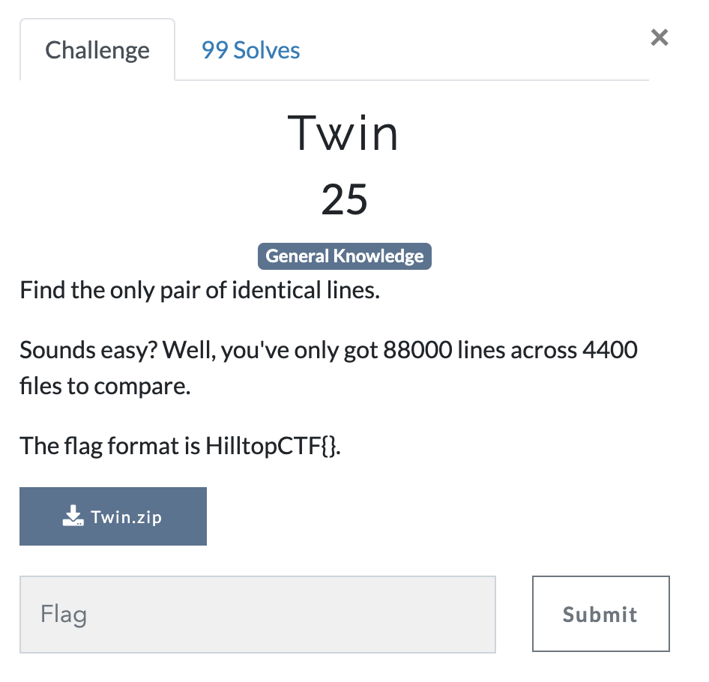
Answer: We have zip file with 4400 files and have to find identical lines. To start lets just unzip the file. Command: unzip Twin.zip
Next lets change directory to the new Twin directory, cat, sort, and display the only duplicated line.

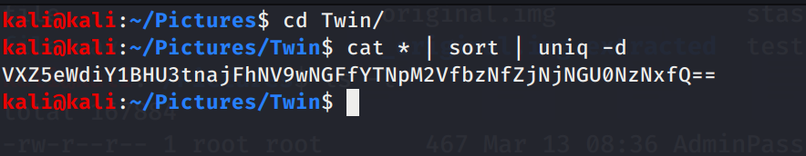
What we are left with is a Base64 string, let’s decode using hURL.
Command: hURL -b VXZ5eWdiY1BHU3tnajFhNV9wNGFfYTNpM2VfbzNfZjNjNGU0NzNxfQ== -s
Looks like we are close, seems to be a rot13 string, hURL to rescue again.
Command: hURL -8 UvyygbcPGS{gj1cleara5_p4a_a3i3e_o3_f3c4e473q} -s
There we go now we have our flag
FLAG: HilltopCTF{tw1n5_c4n_n3v3r_b3_s3p4r473d}

